MAODS Nominations and Winners 2022 – 2026
2026:
ACT SPOTLIGHT AWARDS 2026 – Winners TBC
MAODS - We Will Rock You
Most Accomplished Actress – Rosie Plummer - Scaramouche
Most Accomplished Actor – Alex Cohen - Galileo
Most Accomplished Supporting Actor – Ian Bennett - Khashoggi
Most Accomplished Supporting Actress – Ochi Odey – Killer Queen
Most Accomplished Original Cameo – Katherine Farrow - Oz
Most Accomplished Comic Performance – George Devlin - Madonna
MAODS - Calendar Girls
Most Accomplished Character Actress – Sarah Thewlis - Chris
Most Accomplished Character Actress – Samantha Hughes - Annie
Most Accomplished Supporting Actor – John Wood – John Clarke
Most Accomplished Supporting Actress – Shirley Harrison - Jessie
NXG - Newsies Jr
Most Accomplished Character Actress (Youth) – Georgia Ennis – Medda Larkin
Most Accomplished Character Actor (Youth) – Oliver Cunliffe - Davey
Most Accomplished Supporting Actress (Youth) – Kiera Gardener - Crutchie
Most Accomplished Vocal Ensemble Performance (Youth) – The Ensemble

ACT OUT OF THE SPOTLIGHT 2026
Excellence in Digital Marketing – George Devlin – The Season
Excellence in Stage Craft, Set Design, Construction and Planning – Aaron Smith, Stacey Gentle, Nigel Banks – We Will Rock You
Excellence in Wardrobe – Margaret Perkins, Chris Anderson, Jane Wood & Claire Fletcher – We Will Rock You

GMDF Full Length Festival 2025/26
MOADS - Calendar Girls
Best Supporting Female Actor – Rachel Roberts/Mellor - Ruth
Best Female Actor – Sarah Thewlis - Chris
MOADS - We Will Rock You
Best Supporting Female Actor – Katherine Farrow – Oz
Best Supporting Male Actor – Isaac Brooks – Brit
Best Choreographer – Simon Fitzpatrick
Best Director – Lee Brennan
Best Musical Director – Paul Firth & John Barry
Bets Female Actor – Rosie Plummer – Scaramouche
Technical Award - Staging

NODA D7 2025
MAODS - Calendar Girls
Best Comedy Performance – George Devlin - Tommo
Best Ensemble Performance – Sunflower of Yorkshire
Best Vocal Performance – Sarah Thewlis – Sunflower (NODA SHINING STAR)
Best Leading Female Character – Sarah Thewlis – Chris
Best Leading Female Character – Samantha Hughes - Annie
Best Leading Female Character – Jo Bell - Celia
Best Choreographer – Jane Wood
Best Director – Jo Weetman
Best Musical Director – Paul Firth
Best Musical
Best Staging of a Musical
MAODS - Annie
Best Leading Male Chaarcter – John Wood – Daddy Warbucks
Best Leading Female Character – Sylvie Hoyle - Annie
Best Leading Female Character – Laura M Hoyle - Grace
Best Leading Female Character – Paul Firth – Miss Hannigan
Best Choreographer – Katherine Farrow
Best Director – Samantha Hughes
Best Musical Director – Paul Firth
Best Musical
Best Youth Performance in a Musical – Sylvie Hoyle – Annie
Best Programme – George Devlin - Annie

2025:
ACT Spotlight Nominations 2024/2025:
MAODS – Sister Act
Most Accomplished Actress – Kayleigh Ann Strong – Deloris Van Cartier
Most Accomplished Vocal Ensemble – The Nuns
Most Accomplished Character Actor – Rob Haslam – Curtis
Most Accomplished Actresses – Claire Egerton, Samantha Hughes & Rosie Plummer – Sister Mary Patrick, Lazerus & Robert.
Most Accomplished Character Actors – Jon Crebbin, Nick Ward & John Harrison – Joey, Pablo & TJ
Most Accomplished Supporting Actor – Samuel Maurice – Sweaty Eddie
Most Accomplished Supporting Actress – Shirley Harrison – Mother Superior
MAODS – Annie
Most Accomplished Actor – John Wood – Daddy Warbucks
Most Accomplished Vocal Ensemble – The Orphans
Most Accomplished Youth in an Adult Musical – Sylvie Hoyle – Annie
Most Accomplished Supporting Actress – Laura Meredith Hoyle – Grace Farrell
Most Original Cameo Role – Molly Griffiths – Lily St. Regis
Most Creative Dance Architect – Katherine Farrow
NXG – Charlie & The Chocolate Factory (Play)
Most Accomplished Actor – Jack Schofield – Charlie Bucket
Most Accomplished Actress – Lucy Hallam – Wonka
Most Accomplished Supporting Actor – Nell Swettenham – Mike Teavee
Most Accomplished Supporting Actor – Aalyah Bray – Augustus Gloop
Most Accomplished Supporting Actress – Keira Gardener - Narrator
Most Accomplished Supporting Actress – Lexi O’Mara – Violet Beauregard
Most Accomplished Supporting Actress – Lucille Turner – Veruca Salt

GMDF Full Length Festival 2024/25
MAODS – Sister Act
Best Female Actor – Kayleigh Ann Strong – Deloris Van Cartier
Best Female Actor – Shirley Harrison – Mother Superior
Best Male Actor – Samuel Maurice – Eddie Souther
Best Supporting Female Actor – Rosie Plummer – Sister Mary Roberts
Best Supporting Male Actor – Rob Haslam – Curtis
Best Choreographer – Jane Wood
Best Director – John Wood
MAODS – Annie
Best Youth Performer in an Adult Production – Sylvie Hoyle – Annie
Best Male Actor – Paul Firth – Miss Hannigan
Best Supporting Female Actor – Laura Meredith Hoyle – Grace Farrell
Best Supporting Male Actor – Nick Ward – Rooster Hannigan
Best Supporting Male Actor – Mat Hepplestone – Various Cameo Roles
Best Musical Director – Paul Firth and John Barry
Best Director - Samantha Hughes
Adjudicator’s Award – The Orphans
Best Musical – Annie

ACT Out of the Spotlight:
Costumes and Wardrobe – Margaret Perkins and Chris Anderson – Sister Act
Costumes and Wardrobe – Margaret Perkins and Chris Anderson – Annie
Technical – Stacey Gentle and Aaron Smith – Sister Act

2024:
NODA (Adult Musicals Category) 2024
MAODS - GHOST The Musical:
Best Comedy Performance – Ochi Odey, Oda Mae Brown
Best Supporting Male Character – Mat Hepplestone, Willie Lopez
Best Supporting Male Character – Samuel Maurice, Carl Bruner
Best Leading Female Character – Katherine Farrow, Molly Jensen
Best Choreographer – Molly-Mae France
Best Director – Ian Bennett
Best Musical Director – Paul Firth
Best Musical – GHOST the Musical

MAODS - Sister Act:
Best Leading Female Character – Kayleigh Ann Strong, Deloris Van Cartier
Best Leading Female Character – Shirley Harrison, Mother Superior
Best Supporting Female Character – Samantha Hughes, Sister Mary Lazarus
Best Supporting Male Character – Samuel Maurice, Sweaty Eddie
Best Choreographer – Jane Wood
Best Director – John Wood
Best Musical Director – Paul Firth
Best Ensemble – The Nuns, Raise Your Voice
Best Musical – Sister Act

NODA (Youth Drama Category)
NXG - Charlie & The Chocolate Factory:
Best Supporting Female Character – Lucille Turner, Veruca Salt
Best Leading Male Character – Lucy Hallam, Wonka
NODA (Youth Musical Category)
NXG - Into the Woods Jr:
Best Comedy Performance – Lexi O’Mara, Milky White
Best Supporting Female Character – Aoife Etchells, Little Red
Best Choreographer – Paige Ryan
Best Director – Ty Mather
Best Staging of a Youth Production – Into the Woods Jr

ACT Spotlight (Musicals Category)
MAODS – School of Rock:
Most Accomplished Actor – Nick Ward, Ned Schneebley
Most Accomplished Dance Concept – Katherine Farrow
Most Accomplished Vocal Ensemble Performance – The Company
Most Accomplished Comic Performance – Matt Ogden, Dewey Finn
Most Accomplished Youth Performer – Sylvie Hoyle, Summer
Most Accomplished Youth Performer – Freddy Pooley, Zack
Most Accomplished Actress – Philippa Shellard, Rosalie Mullins

MAODS – GHOST the Musical:
Most Accomplished Actor – John Dean, Sam Wheat
Most Accomplished Actress – Katherine Farrow, Molly Jensen
Most Accomplished Supporting Actor – Samuel Maurice, Carl Bruner
Most Original Cameo Role – Ty Mather, Subway Ghost
Most Accomplished Supporting Actress – Ochi Odey, Oda Mae Brown

NXG – Into the Woods Jr
Most Accomplished Actress – Nancy Fletcher, The Narrator
Most Original Comic Performance – River Connell, Rapunzel’s Prince
Most Accomplished Dance Concept – Paige Ryan
Most Accomplished Comic Performance – Lucy Hallam, Cinderella’s Prince
Most Accomplished Character Actress – Georgia Ennis, The Witch

ACT Out of The Spotlight:
Programme – George Devlin – Ghost The Musical
Costumes and Wardrobe – Margaret Perkins & Chris Anderson – School of Rock

GMDF (Musicals Category) Nominations and Winners:
MAODS - School of Rock:
Best Male Actor – Matt Ogden, Dewey Finn
Best Female Youth Actor – Sylvie Hoyle, Summer
Best Male Youth Actor – Freddy Pooley, Zack
Best Male Youth Actor – Oliver Cunliffe, Billy
Best Choreographer – Katherine Farrow
Best Director – Samantha Hughes

MAODS - Ghost the Musical:
Best Female Supporting Actor – Ochi Odey, Oda Mae Brown
Best Male Supporting Actor – Samuel Maurice, Carl Bruner
Technical Award – Ghost the Musical
Best Musical Director – Paul Firth

NODA (Adult Musicals Category) Nominations and Winners 2023
MAODS – The Bridges of Madison County:
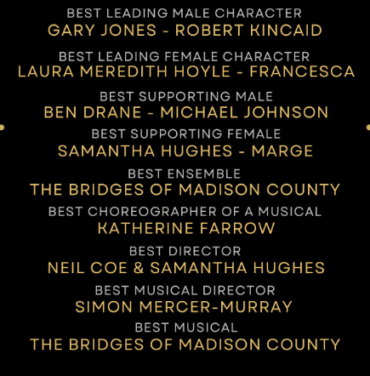

MAODS – School of Rock:
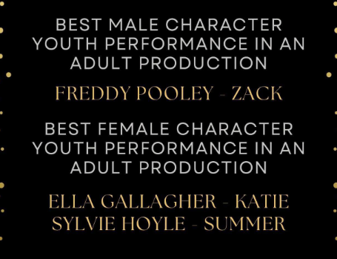
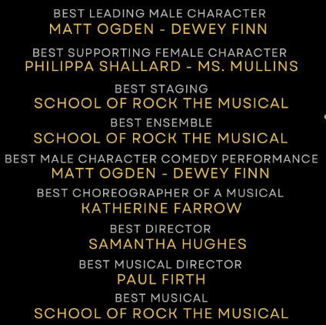
Winners:
Best Leading Male Character - Matt Odgen, Dewey Fin
Best Male Character Youth Performance – Freddy Pooley, Zack

ACT (Adult Musicals Category) Nominations and Winners 2023
MAODS – OLIVER!:
Most Accomplished Actor:
Jack Knight, Fagin
Nick Ward, Bill Sykes
Most Accomplished Actress – Felicity Pretsell, Nancy
Most Accomplished Dance Concept – Katherine Farrow / Jane Wood
Most Accomplished Youth in an Adult Production – Callum Beswick, Oliver Twist
Most Accomplished Supporting Actor – Mat Hepplestone, Mr Sowerberry
Most Accomplished Supporting Actress – Sarah Thewlis, Widow Corney

MAODS – The Bridges of Madison County:
Most Accomplished Actress – Laura Meredith Hoyle, Francesca
Most Accomplished Actor – Gary Jones, Robert
Most Accomplished Supporting Actor – Jon Crebbin, Bud
Most Accomplished Cameo Role – Helen Rose, Ex Wife
Most Accomplished Vocal Ensemble – The Company

NXG – Seussical Jr:
Most Accomplished Dance Concept – Molly-Mae France
Most Accomplished Character Performance – Ella Gallagher, Cat
Most Accomplished Character Development – Rose Hadfield, Horton
Most Accomplished Character Performance – Lucy Morris, Gertrude
Most Accomplished Character Performance – Georgia Ennis, Sour Kangaroo
Most Accomplished Character Performance – Freddy Pooley, Jojo
Most Accomplsihed Actress – Maya Wainwright, Mayzie La Bird
Most Accomplished Ensemble – The Company

GMDF (Adult Musical Category) Nominations and Winners 2023:
MAODS - OLIVER!
Best Male Actor – Jack Knight, Fagin
Best Supporting Male Actor – Nick Ward, Bill Sykes
Best Male Youth Performer – Liam Brophy, Charley Bates
Best Male Youth Performer – Callum Beswick, Oliver Twist
Best Staging – Technical Award
Best Choreography – Katherine Farrow
Best Director – Samantha Hughes

MAODS - The Bridges of Madison County:
Best Male Actor – Gary Jones, Robert Kincaid
Best Supporting Female Actor – Samantha Hughes, Marge
Best Supporting Male Actor – Jon Crebbin, Bud Johnson
Best Director – Neil Coe
Best Musical Director – Simon Mercer-Murray

NODA (Adult Musical Category) Nominations and Winners 2022
MAODS – Shrek! The Musical
Best Male Comedy Performance – John Wood, Shrek
Best Male Comedy Performance – Samuel Maurice, Donkey
Best Staging – Shrek! The Musical
Best Ensemble – Fairytale Folk
Best Ensemble – The Rats
Best Leading Female – Laura Meredith Hoyle, Princess Fiona
Best Choreography – Jane Wood
Best Director – Ian Bennett
Best Musical – Shrek! The Musical
Special Achievement in Theatre Award - Shrek! The Musical

MAODS – OLIVER!
Best Male Comedy Performance – Jack Knight, Fagin
Best Supporting Male – Mat Hepplestone, Mr Sowerberry
Best Supporting Female – Katherine Farrow, Bet
Best Staging – OLIVER!
Best Ensemble – Fagin’s Gang
Best Leading Female – Felicity Pretsell, Nancy
Best Leading Male – Jack Knight, Fagin
Best Choreography – Katherine Farrow
Best Director – Samantha Hughes
Best Musical – OLIVER!

